*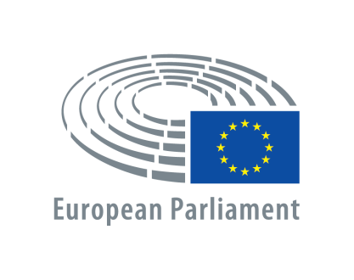**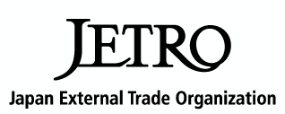*

**High-level conference of political, industrial and academic leaders**

**ADAPTING TO THE CHANGING WORLD THROUGH  
SCIENCE, TECHNOLOGY AND INNOVATION**

**Strengthening cooperation between the STS *forum* and the EU**

***4 May 2016, 14:00 - 18:00***

***Paul Henri Spaak building, Yehudi Menuhin space***

***European Parliament, Brussels***

STOA | Science and Technology Options Assessment

STS *forum* | Science and Technology in Society *forum*

JETRO| Japan External Trade Organization

Draft programme

|  |  |
| --- | --- |
| **Chair: Paul RÜBIG**, MEP, Chairman of STOA | |
| **TIME** | **SPEAKERS** |
| 14:00 - 14:15 | **Opening Remarks** |
| * **Paul RÜBIG**, MEP, Chairman of STOA * **Koji OMI**, Founder and Chairman of STS *forum* * **Hiroyuki ISHIGE**, Chairman, JETRO |
| 14:15 - 14:45 | **Keynote Speeches** |
| * (EU Council/Commission) (t.b.c.) * **Kazuo TODANI**, Deputy Minister, Ministry of Education, Culture, Sport, Science and Technology * **Markus BEYRER**, Director General, BUSINESSEUROPE * **Takeo HOSHINO**, Deputy Director-General, Ministry of Economy, Trade and Industry |
| 14:45 – 15:45 | **Panel I: ‘*Open Science in an Open World*’**  **chaired by Harriet WALLBERG, Karolinska Institutet**  (STS *forum)* |
| * **Michinari HAMAGUCHI**, President, Japan Science and Technology Agency * **Ismail SERAGELDIN**, Director, Library of Alexandria * **Mathias KLEINER**, President, Leibniz Association   (EU)   * **Helmut LIST**, CEO, AVL LIST GmbH * **Kay SWINBURNE**, MEP, Member of STOA Panel * **Jean-Pierre BOURGUIGNON**, President, European Research Council |
| 15:45 – 16:00 | **Coffee break** |
| 16:00 – 17:00 | **Panel II: ‘*Open Innovation for Sustainable Development*’**  **chaired by Martin KERN, Interim Director, EIT**  (STS *forum*)   * **Pascal COLOMBANI**, Chairman of Board of Directors, Valeo * **Ryoji CHUBACHI**, President, National Institute of Advanced Industrial Science and Technology (AIST);   former President and CEO, Sony Corporation   * **Masahisa NAGATA**, Managing Officer,   Toyota Motor Corporation (t.b.c.)   * **Yoichiro, MATSUMOTO**, Executive Director, RIKEN   (EU)   * **Egbert LOX**, SVP Government Affairs, Umicore * **François DARCHIS**, Executive Committee member, Air Liquide * **Henrik C. WEGENER**, Chair, SAM High-Level Group * **Thomas MÜLLER-KIRSCHBAUM**, Corporate Senior Vice-President, Research & Development, Henkel AG & Co , KGaA (t.b.c.) |
| 17:00 – 17:10 | **Closing Remarks**   * **Paul RÜBIG**, MEP, Chairman of STOA * **Koji OMI**, Founder and Chairman of STS *forum* |
| 17:10 – 18:00 | **Networking Time** |

Please be informed: This workshop will be conducted in English, without interpretation.