Green Energy Technologies Business Mission
Singapore & Philippines 23 – 27 October 2017

Singapore aims to reduce energy intensity by 35% from 2005’s level by 2030. In 2013, Singapore became Asia’s first self-sustaining photovoltaic market. The Philippines’ National Renewable Energy Program aims to expand capacity of green energy from 6.63 GW in 2015 to 15.30 GW in 2030. This provides up to 50% of the country’s electricity generation. Demand for technologies is high and opportunities for EU companies in the Green Energy Technologies sector are diverse.
European companies active in Green Energy Technologies can apply for a business mission to Singapore & the Philippines, to be held in October 2017
EU Gateway | Business Avenues is an exclusive initiative supported by the European Union. Driven by business opportunities, the programme accelerates high potential European companies in Asian markets through sector-focused business missions organised in key markets.
EU Gateway | Business Avenues will take up to 50 selected European companies to Singapore & the Philippines, from 23 – 27 October 2017 for a business mission on Green Energy Technologies. Participants will have:

- Privileged access to focused business opportunities
- Targeted meetings with potential business partners and key contacts
- The chance to visit the Singapore International Energy Week 2017
- Market intelligence in terms of a comprehensive market study
- Internationalisation coaching and support on doing business in the target markets
- Business support during and after the mission to facilitate any deals
- Access to co-financing by the European Union for some of the main costs

Key information and how to apply:

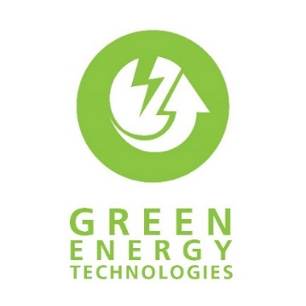 | When: | 23 – 27 October 2017
 | Where: | Singapore & Philippines
 | Application deadline: | 16 June 2017
 | Find out more & submit your application: | https://www.eu-gateway.eu/business-missions/missions-calendar/green-energy-technologies-singapore-philippines
 | Questions: | Coaching.Network@eu-gateway.eu

