Healthcare & Medical Technologies Business Mission
Shanghai, China 04 – 08 December 2017

China’s health system as seen significant reforms in the past decade, providing its population with greater access to care and medical technologies. An ageing population, lifestyle changes, increasing awareness of diseases and the growing affordability of health insurance coverage fuel the demand for healthcare and medical technologies.
European companies active in Healthcare & Medical Technologies can apply for a business mission to Shanghai, China, to be held in October 2017
EU Gateway | Business Avenues is an exclusive initiative supported by the European Union. Driven by business opportunities, the programme accelerates high potential European companies in Asian markets through sector-focused business missions organised in key markets.
EU Gateway | Business Avenues will take up to 50 selected European companies to China from 04 – 08 December 2017 for a business mission on Healthcare & Medical Technologies. Participants will have:

- Privileged access to focused business opportunities
- Targeted meetings with potential business partners and key contacts
- Site visits to gain insights into the Chinese Healthcare & Medical Technologies sector
- Market intelligence in terms of a comprehensive market study
- Internationalisation coaching and support on doing business in China
- Business support during and after the mission to facilitate any deals
- Access to co-financing by the European Union for some of the main costs
Key information and how to apply:

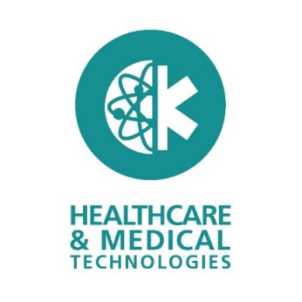 |  | When: | 04 – 08 December 2017
 |  | Where: | Shanghai, China
 |  | Application deadline: | 23 June 2017
 |  | Find out more & submit your application: | https://www.eu-gateway.eu/business-missions/missions-calendar/healthcare-medical-technologies-china
 |  | Questions: | Coaching.Network@eu-gateway.eu

