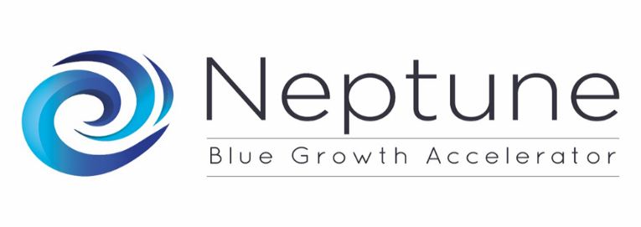
Register for the NEPTUNE Online International Brokerage Event (IBE): Gateway to the NEPTUNE Blue Growth Accelerator Support Programme
June the 8th 2017
NEPTUNE project partners will organise an online International Brokerage Event (IBE) on June the 8th.
The NEPTUNE International Brokerage Event (IBE), is the opportunity to meet and exchange with SMEs or entrepreneurs from different sectors and countries with potential projects or ideas for the NEPTUNE Blue Growth Accelerator call, or to exchange and develop project ideas with the NEPTUNE Expert providers, potential end-users / customers (individual or panel) and advisory board members of NEPTUNE clusters.

Register and plan your meeting

.
